Short documentation about how to use sample shaders

osg::ref_ptr<ARScene> arScene = new ARScene;
arScene->init(tracker);

int videoBGWidth = video->getWidth();
int videoBGHeight = video->getHeight();

// To apply shader effects to background, you need to initialise the // background as texture. ARScene adds a DummyImageLayer by default // for the background and the foreground. However, you can tell it
// not to add the DummyImageLayer.
// Make sure you initialise background first then the foreground.

osg::ref_ptr<osg::Texture> backgroundTexture =
arScene->initTextureVideoBackground(
video->getId(), videoBGWidth/10, videoBGHeight/10);

osg::ref_ptr<osg::Texture> foregroundTexture =
arScene->initTextureForeground(videoBGWidth/10, videoBGHeight/10);

osg::ref_ptr<DummyImageLayer> bgLayer =
arScene->getBackgroundDummyLayer();

ShaderFactory sf; // this loads shaders to a Node.

// Note that 2D effect can be applied to the background, the
// foreground or both.
// 3D effect can only be applied directly to the models

2D Effects

Half Tone

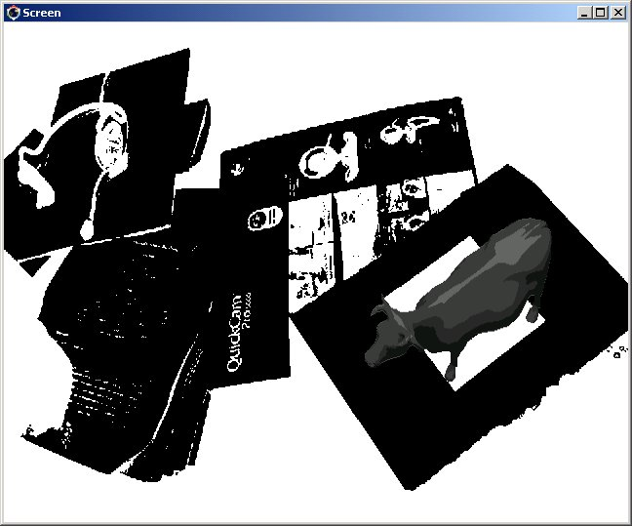

sf.addFragmentShaderFromFile("./data/shader/HalfTone.frag", bgLayer.get());

Sepia

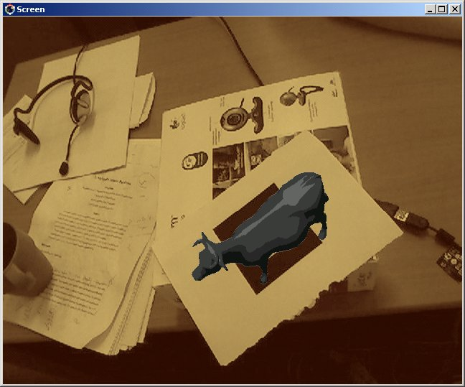

sf.addFragmentShaderFromFile("./data/shader/Sepia.frag",
bgLayer.get());

Tile

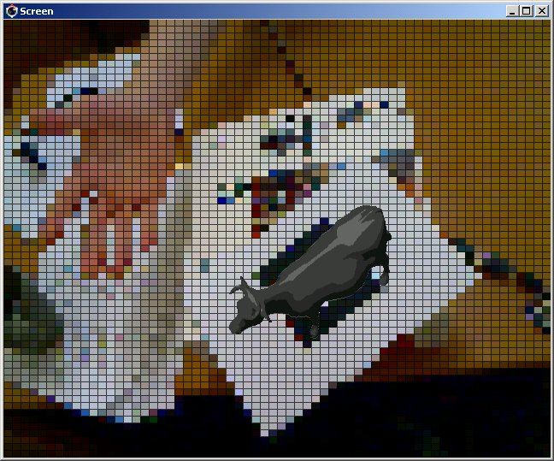

sf.addFragmentShaderFromFile("./data/shader/Tile.frag",
bgLayer.get());
// set width and height of background image
bgLayer->getOrCreateStateSet()->addUniform(
new osg::Uniform("imageDimension", osg::Vec2f( videoBGWidth, videoBGHeight)));

// set number of column and row
bgLayer->getOrCreateStateSet()->addUniform(
new osg::Uniform("tileSize",
osg::Vec2f( (float)videoBGWidth/10.0f,(float)videoBGWidth/10.0f)) );

Radial Blur 1

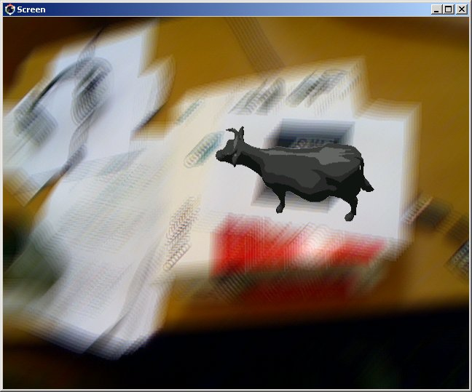

sf.addVertexAndFragmentShaderFromFile(
"./data/shader/Radialblur1.vert",
"./data/shader/Radialblur.frag",
bgLayer.get());

bgLayer->getOrCreateStateSet()->addUniform(
new osg::Uniform("imageDimension",
osg::Vec2f( videoBGWidth, videoBGHeight)));

// blur direction in 2D vector (-1.0, -1.0)
// blur length (or shifting value) of 5 pixel
bgLayer->getOrCreateStateSet()->addUniform(
new osg::Uniform("blurDirectionAndLength",
osg::Vec3f(-1.0,-1.0, 5) ));

// Repeat 8 times.
// however I hard coded repeating number in the for-loop because
// variable somehow doesn’t work in for-loop in fragment shader
bgLayer->getOrCreateStateSet()->addUniform(
new osg::Uniform("numToRepeat", 8) );

Radial Blur 2

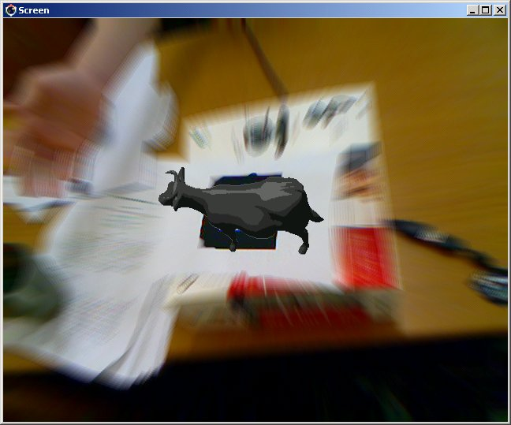

sf.addVertexAndFragmentShaderFromFile(
"./data/shader/Radialblur2.vert",
"./data/shader/Radialblur.frag",
bgLayer.get());

bgLayer->getOrCreateStateSet()->addUniform(
new osg::Uniform("imageDimension", osg::Vec2f( videoBGWidth, videoBGHeight)));
// set the center position of blur
bgLayer->getOrCreateStateSet()->addUniform(
new osg::Uniform("centerPos",
osg::Vec2f(videoBGWidth/2.0, videoBGHeight/2.0)) );

// radius of non-blured area in texture coordinate and shifting value
// 0.01 in texture coordinate
bgLayer->getOrCreateStateSet()->addUniform(
new osg::Uniform("radAndLength", osg::Vec2f(0.125, 0.01)) );

bgLayer->getOrCreateStateSet()->addUniform(
new osg::Uniform("numToRepeat", 8) );

Swirl

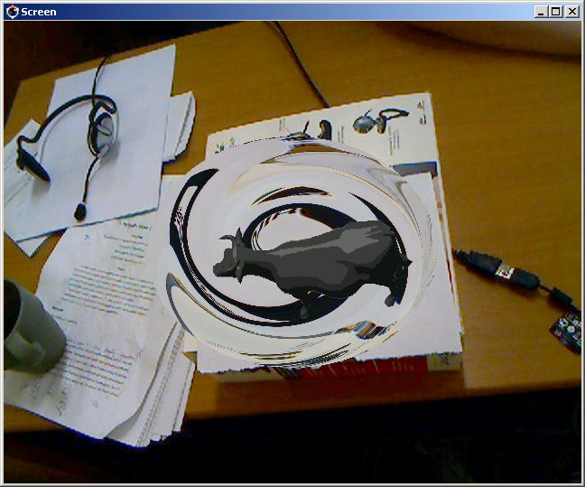

sf.addVertexAndFragmentShaderFromFile(
"./data/shader/Swirl.vert", "./data/shader/Swirl.frag", bgLayer.get());

bgLayer->getOrCreateStateSet()->addUniform(
new osg::Uniform("imageDimension",
osg::Vec2f( videoBGWidth, videoBGHeight)));

bgLayer->getOrCreateStateSet()->addUniform(
new osg::Uniform("centerPos",
osg::Vec2f(videoBGWidth/2.0, videoBGHeight/2.0)) );

// set radius of Swirl
bgLayer->getOrCreateStateSet()->addUniform(
new osg::Uniform("radius", 0.25f) );

3D Effects

Cartoon Shading

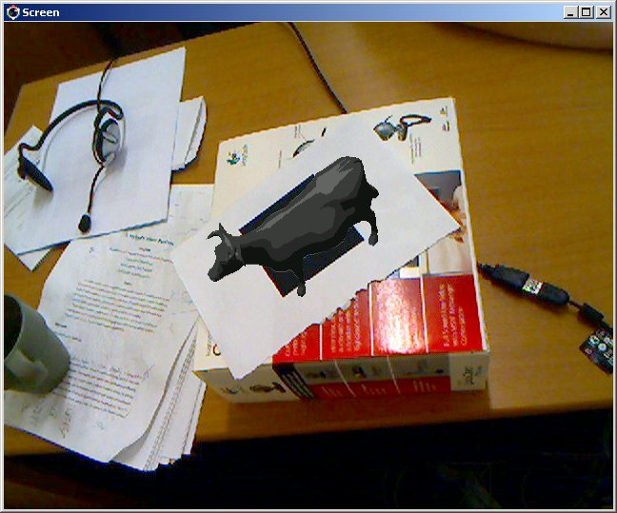

sf.addVertexAndFragmentShaderFromFile(
"./data/shader/CartoonShader.vert",
"./data/shader/CartoonShader.frag", modelNode.get());

Gooch Shading

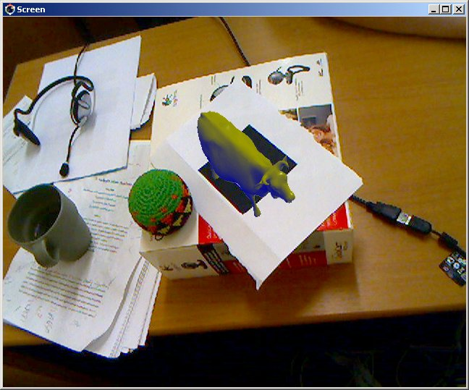

sf.addVertexAndFragmentShaderFromFile("./data/shader/Gooch.vert",
"./data/shader/Gooch.frag",
model.get());
// lightPos is osg::Vec3f
model->getOrCreateStateSet()->addUniform(
new osg::Uniform("lightPos",lightPos) );

Simple Glass Refraction

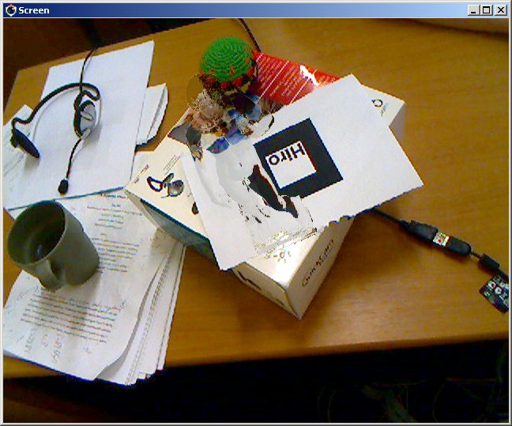

sf.addVertexAndFragmentShaderFromFile(
"./data/shader/GlassRefraction.vert", "./data/shader/GlassRefraction.frag", model.get());

// set background texture
model->getOrCreateStateSet()->setTextureAttributeAndModes(
0, backgroundTexture.get() ,osg::StateAttribute::ON);

model->getOrCreateStateSet()->addUniform(
new osg::Uniform("lightPos",lightPos) );

// note this is not accurate glass refraction.
// for glass it refracts two times ( when the light enters the glass
// and when it leaves the glass )

Brick Shader
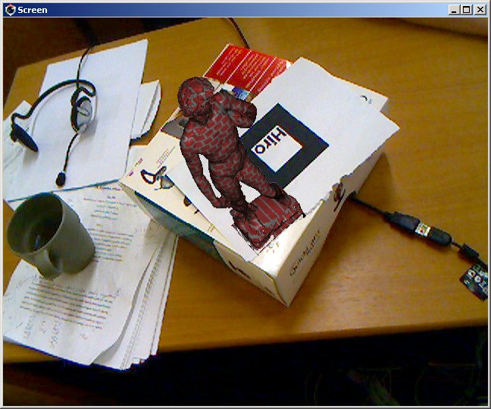

sf.addVertexAndFragmentShaderFromFile("./data/shader/Brick.vert",
"./data/shader/Brick.frag", truckModel.get());

truckModel->getOrCreateStateSet()->addUniform(
new osg::Uniform("lightPos",lightPos) );

// set column and row number for the brick
truckModel->getOrCreateStateSet()->addUniform(
new osg::Uniform("colRowNum", osg::Vec2f(200,100)) );

// ratio of brick (80% are red 20 % are red )
truckModel->getOrCreateStateSet()->addUniform(
new osg::Uniform("brickRatio", osg::Vec2f(0.8,0.8)) );

// note that it is not done by texture mapping but dividing 3D
// coordinate of model into rows and columns and giving different
// color

